Nonlinear Optimization HW1

Shuowen Wei

Problem 1.

clc;clear

% figure 1

t=0:0.01:10;

x=sin(2*t)-cos(t)/2;

y=sin(t);

subplot(2,2,1),plot(t,x,'b','LineWidth',3);grid on

title('plot');

subplot(2,2,2),plot3(t,x,y,'r','LineWidth',2);grid on

title('plot3');

subplot(2,2,3),fplot(@(x)(sin(x)+cos(x*x)), [-2 2]);grid on

title('fplot');

subplot(2,2,4),plot3(t,x,y,'r','LineWidth',2);grid on;view(180,90)

title('view of plot3 in above figure');

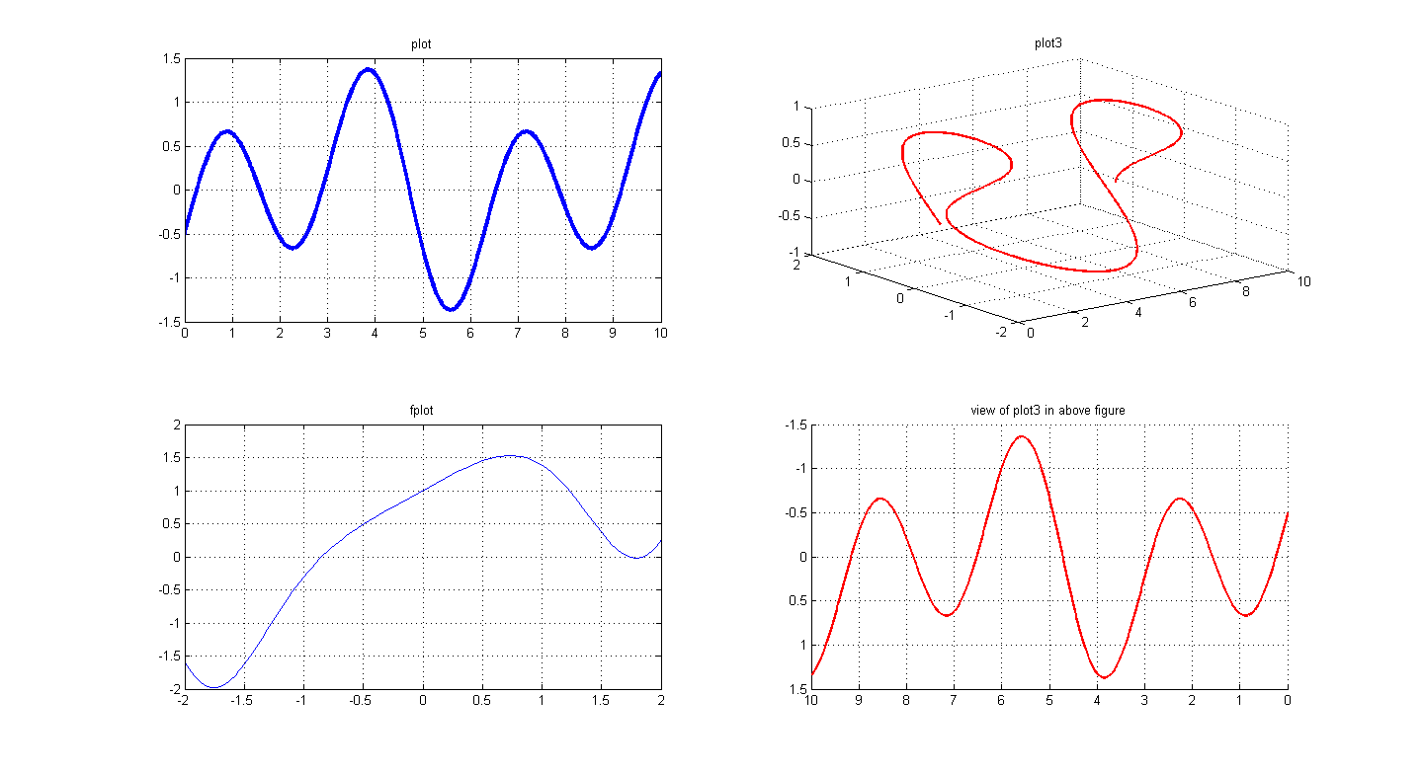

% figure 2

[X,Y]=meshgrid(-10:0.05:10);

R=X+Y;

Z=cos(R).*R;

mesh(X,Y,Z)

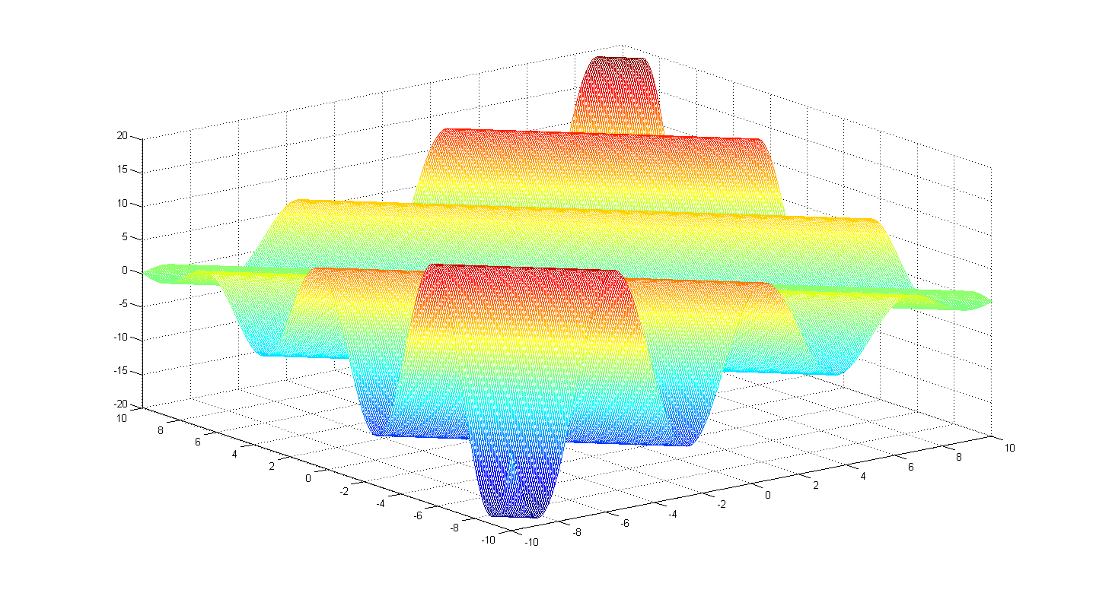

% figure 3

[X,Y]=meshgrid(-10:0.05:10);

R=sqrt(X.^2+Y.^2);

Z=cos(R).*R;

contour(X,Y,Z);colorbar;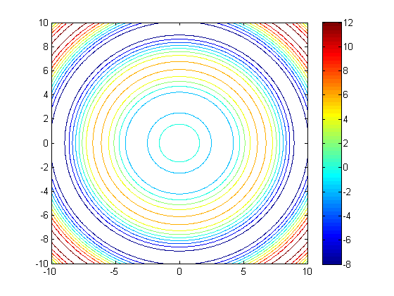

Problem 2.

(a).

% Probelm 2.1

x=[-2:0.01:2];

y_1=sqrt(4-x.^2);

y_2=-sqrt(4-x.^2);

plot(x,y_1,'b',x,y_2,'b','LineWidth',3);

axis([-2.5 2.5 -2.5 2.5])

xlabel('x');ylabel('y');grid on;

title('Problem 2.1');legend('x^2+y^2=4')

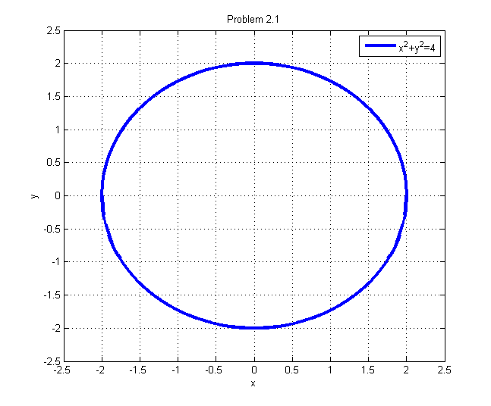

(b).

%Problem 2.2

clc;clear

fplot(@(x)(11-x^2),[-10,10],'b','-.');

hold on;fplot(@(x)(sqrt(7-x)),[-7,7],'r');

hold on;fplot(@(x)(-sqrt(7-x)),[-7,7],'r');

hold off;

legend('blue: x^2+y=11','red: x+y^2=7');

xlabel('x');ylabel('y');title('Problem 2.2');

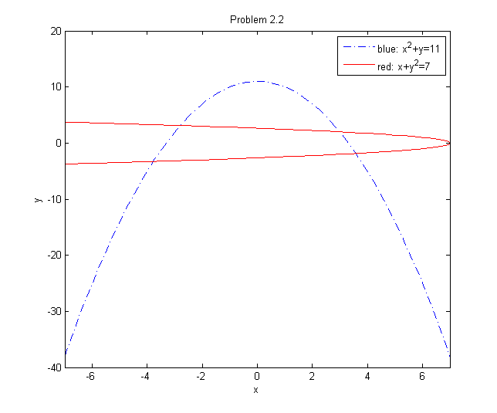

(c).

%Problem 2.3

t=[-4*pi:0.01:4*pi];

x=cos(t);y=sin(2*t);z=t.^2;

plot3(x,y,z,'b','LineWidth',3)

legend('x=cos(t), y=sin(2t), z=t^2');

xlabel('x');ylabel('y');zlabel('z');

title('Problem 2.3');

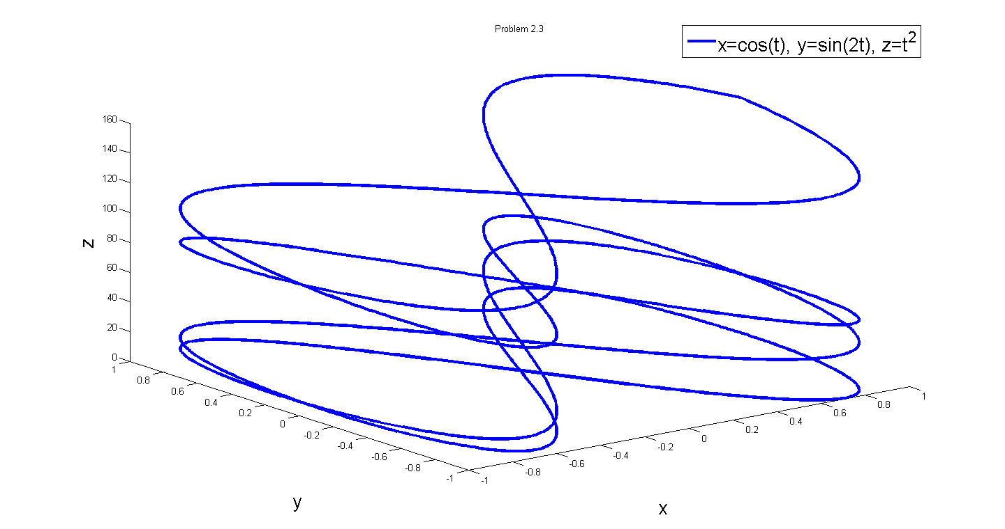

(d).

%Problem 2.4

[x,y]=meshgrid(-3:0.1:3);

z=cos(x+y)+1/2/pi*exp(-x.^2-y.^2);

mesh(x,y,z);

legend('z=cos(x+y)+1/2/pi*exp(-(x^2+y^2)');

xlabel('x');ylabel('y');zlabel('z');

title('Problem 2.4 -- mesh');

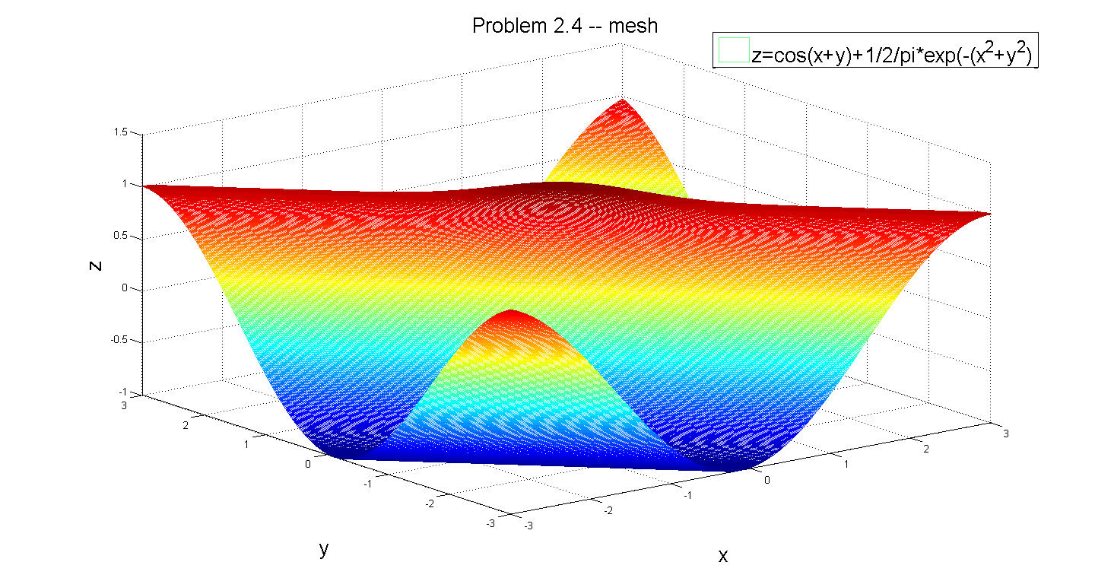

figure

surf(x,y,z,z);

legend('z=cos(x+y)+1/2/pi*exp(-(x^2+y^2)');

xlabel('x');ylabel('y');zlabel('z');

title('Problem 2.4 -- surf');

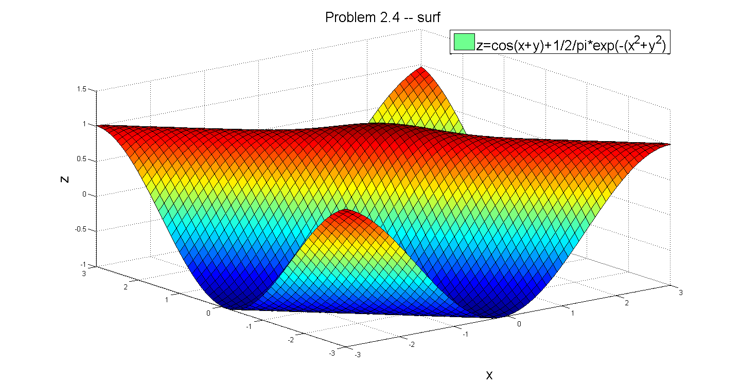

figure

contour(z)

[C,h] = contour(x,y,z);

set(h,'ShowText','on','TextStep',get(h,'LevelStep')*2)

colormap cool

legend('z=cos(x+y)+1/2/pi*exp(-(x^2+y^2)');

xlabel('x');ylabel('y');zlabel('z');

title('Problem 2.4 -- contour');

